Build a Langchain Streamlit Chatbot for EDA using LLMs Project Overview
Overview
Data analysis and visualization play a pivotal role in modern business operations, providing invaluable insights that drive strategic decision-making and organizational success. For business stakeholders, the ability to interpret and derive meaning from vast datasets is crucial in understanding market trends, customer behavior, and operational performance. Data analysis enables stakeholders to identify patterns, correlations, and outliers within datasets, uncovering hidden opportunities and potential risks. Visualization complements this process by transforming complex data into intuitive charts, graphs, and dashboards, facilitating clear and concise communication of insights. Large Language Models (LLMs) present a paradigm shift in how non-technical stakeholders interact with data. These powerful natural language processing models enable users to converse with data in plain language, bypassing the need for specialized technical skills or assistance from data experts. By leveraging LLMs, non-technical stakeholders can directly query data, receive relevant insights, and make informed decisions in real-time, without relying on intermediary teams. This project involves the development of a Streamlit chatbot integrated with lanchain and open ai to facilitate conversational interactions with a SQL database. Leveraging Langchain framework, the chatbot interprets natural language instructions provided by the user, generating corresponding SQL queries to extract relevant data from the database. Through seamless integration with data visualization libraries such as Matplotlib or Plotly, the chatbot dynamically generates python code to create visualizations based on the retrieved data, offering insightful insights and analytics in response to user queries.

Aim
The aim of the project is to develop a Streamlit chatbot integrated with Langchain
technology, enabling natural language interactions with a SQL database to generate
visualizations and provide insights in real-time. Through this, the project seeks to
streamline data exploration and analysis processes, making them more intuitive and
accessible to users.

Data Description
The e-commerce dataset consists of 7 interconnected datasets covering distribution
centers, user events, inventory items, order details, products, and user profiles.
● Distribution Centers dataset: Contains information about distribution centers
including unique identifiers, names, and geographical coordinates.
● Events dataset: Provides details about user events including unique identifiers,
timestamps, user IDs, session IDs, and event types.
● Inventory Items dataset: Includes data on inventory items such as unique
identifiers, timestamps for creation and sale, product details, and distribution
center associations.
● Order Items dataset: Contains information on ordered items including unique
identifiers, timestamps for creation, shipping, delivery, and return, along with
associated product and user IDs.
● Orders dataset: Provides details about orders including unique identifiers,
timestamps for creation, shipping, delivery, and return, along with order status
and quantity of items.
● Products dataset: Includes information about products such as unique identifiers,
costs, retail prices, categories, brands, and distribution center associations.
● Users dataset: Contains user profiles with details like unique identifiers, names,
email addresses, demographics, location coordinates, traffic sources, and
account creation timestamps.

Tech Stack
➔ Language: Python 3.10.4
➔ Libraries: mysql-connector-python, mysqlclient, pydantic, langchain, matplotlib,
plotly, streamlit
➔ Model: Open AI GPT-4

Approach
● Database Creation:
○ Install the MYSQL and MYSQL workbench on your system
○ Creating a new MYSQL database and loading the CSVs in to the
database
● Prompt Engineering Strategies:
○ Acting as a Role
○ Language Translation
○ Travelling Guide
○ Combining LLMs and Prompts in multi-step workflows
● Langchain Integration:
○ Creating SQL agent that transform natural language queries into SQL
queries
○ Creating Python script agent that creates visualizations from SQL query
outputs
● Streamlit Chatbot Creation
● Integrating Memory and Guardrails
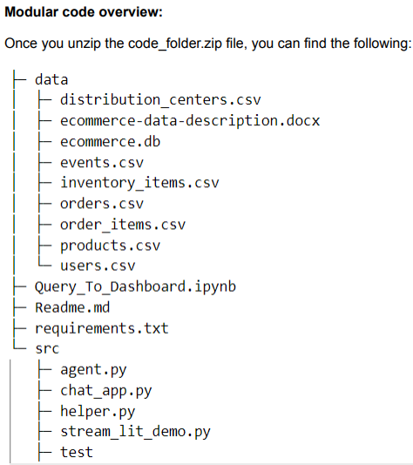

Project Takeaways
1. Understand LLM fundamentals, attention mechanism, and transformer
architecture
2. Learn about various applications of LLMs in different industries
3. Introduction to Langchain and its functionalities
4. What is Prompt Engineering?
5. Implement prompt engineering scenarios for communication with LLMs
6. Learn to set up a MYSQL database
7. Understand the complexities involved in generating queries and codes using
LLMs
8. Create Langchain agents for SQL query generation from natural language
9. Create Langchain agents for Python code generation from natural language
10.Gain insight into memory and guardrails, essential concepts in managing and
optimizing the performance of LLMs
11. Development of a Streamlit chatbot interface for intuitive data interaction and
visualization

